Data Flow Diagram & User Stories
Team ID | Date | Project | Maximum Marks
SWTID-2026-1237 | 29/09/2026 | EduGenie | 4 Marks

Data Flow Diagram:
A Data Flow Diagram (DFD) is a traditional visual representation of the information flows within a system. A neat and clear DFD can depict the right amount of the system requirement graphically. It shows how data enters and leaves the system, what changes the information, and where data is stored.

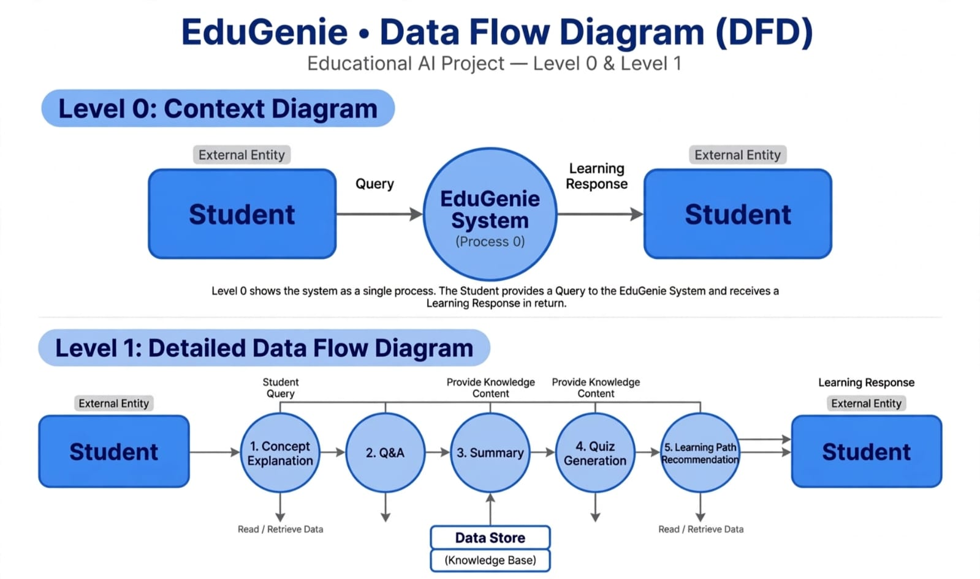

How the Data Flow Diagram Works :
1.Level 0: Context Diagram (Simple Flow)This shows the system as a single process.The Student (External Entity) sends a Query (e.g., "Explain Photosynthesis") to the EduGenie System.
2.The EduGenie System processes the query.
3.The System sends back a Learning Response to the Student.It is a simple input and output cycle.
Level 1: Detailed Flow (How the 5 Concepts Work)
When a student asks a doubt, the data flows through 5 main processes:
1. Concept Explanation: The system retrieves data from the Knowledge Base and explains the tough concept in simple terms.
2. Q&A: It handles follow-up questions from the student and provides instant, accurate answers.
3. Summary: It accesses long content from the Data Store and generates a short, easy-to-revise summary.
4. Quiz Generation: It creates practice questions from the same topic to test the student's understanding.
5. Learning Path Recommendation: Finally, it analyses the student's progress and recommends a personalized learning path.
All 5 processes Read / Retrieve Data from the Data Store (Knowledge Base), which stores all the learning content.
After processing through all 5 concepts, a complete Learning Response is sent back to the Student.

User Stories